**Challenge 1: web design**

Develop a simple website for an online shop

Create 3 web pages, save the notepads in the same folder for accessibility

1- Homepage

2- about us

3-categories

Duplicate the following screenshots with html. Individuality will be an added advantage

**Home page**

This page is linked to the about us and categories pages

Bold the link names

Use the &nbsp code to space the links

Use the color code chart to give color to your pages. Use code bgcolor = *color name* in the body tag

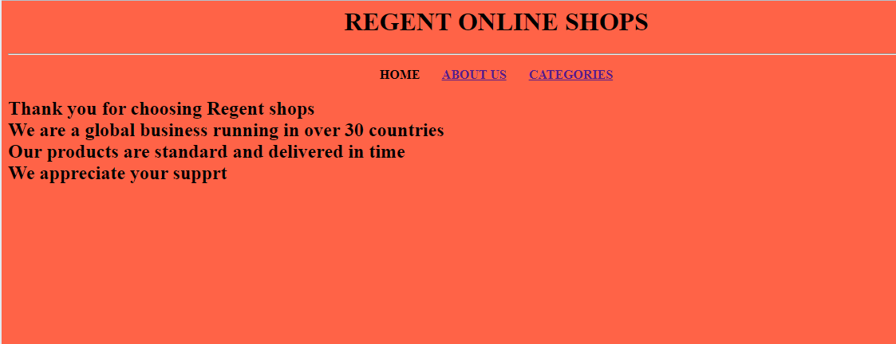

**About us page**

This page is linked to the home and categories pages

Abbreviate No to reflect Number within your code

Email peter should be a mail link

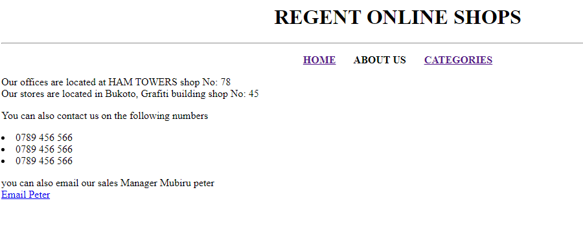

**Categories page**

This page is linked to the home and about us pages

Link the first lists to take you to the specifics in that same document

